EXP.NO-2 | Write JavaScript Programme to validate the following fields of the HTML Registration page

AIM:
To write JavaScript code to validate user input in a registration form. The validation will ensure that the data entered by the user meets specific criteria for each field. This will help in maintaining data integrity and prevent invalid submissions.
ALGORITHM:
Input:
The user fills in the following fields: First Name, Password, E-mail, Mobile Number, Last Name, and Address.
Validation Steps:
1.Validate First Name:
- Check if the first name contains only alphabets.
- Ensure the length of the First Name is at least 6 characters.
- If any of these conditions fail, display an error message indicating the required input.
2. Validate Password:
- Check if the password is at least 6 characters long.
- If it is less than 6 characters, display an error message.
3. Validate E-mail:
- Use a regular expression to check if the email follows the standard pattern: name@domain.com.
- Ensure that the email contains no invalid characters and matches the required pattern.
- If it doesn&#39;t match, display an error message indicating an invalid email format.
4. Validate Mobile Number:
- Check if the mobile number contains exactly 10 digits.
- Ensure there are no alphabets or special characters.
- If the number is invalid, display an error message indicating the correct format.
5. Validate Last Name:
- Ensure the Last Name field is not empty.
- If it is empty, display an error message.
6. Validate Address:
- Ensure the Address field is not empty.
- If it is empty, display an error message.
CODE:
register.html
<!DOCTYPE html>
<html>
<head>
<title>Register | TechScope</title>
<!-- Project style (separate stylesheet) -->
<link rel="stylesheet" href="auth.css">
<script>
function validateForm() {
var fname = document.getElementById("fname").value;
var lname = document.getElementById("lname").value;
var email = document.getElementById("email").value;
var mobile = document.getElementById("mobile").value;
var password = document.getElementById("password").value;
var address = document.getElementById("address").value;
var namePattern = /^[A-Za-z]+$/;
var emailPattern = /^[a-zA-Z0-9._%+-]+@[a-zA-Z0-9.-]+\.[a-z]{2,}$/;
var mobilePattern = /^[0-9]{10}$/;
// First Name
if (!namePattern.test(fname) || fname.length < 6) {
alert("First Name must contain alphabets only and minimum 6 characters");
return false;
}
// Last Name
if (lname === "") {
alert("Last Name cannot be empty");
return false;
}
// Email
if (!emailPattern.test(email)) {
alert("Enter a valid Email ID (name@domain.com)");
return false;
}
// Mobile
if (!mobilePattern.test(mobile)) {
alert("Mobile number must contain exactly 10 digits");
return false;
}
// Password
if (password.length < 6) {
alert("Password must be at least 6 characters long");
return false;
}
// Address
if (address === "") {
alert("Address cannot be empty");
return false;
}
alert("Registration Successful");
return true;
}
</script>
</head>
<body>
<div class="auth-container">
<div class="auth-card">
<h2>Create Account</h2>
<p class="auth-sub">Register to continue with TechScope</p>
<form onsubmit="return validateForm()">
<label>First Name</label>
<input type="text" id="fname" placeholder="Enter first name">
<label>Last Name</label>
<input type="text" id="lname" placeholder="Enter last name">
<label>Email ID</label>
<input type="text" id="email" placeholder="name@domain.com">
<label>Mobile Number</label>
<input type="text" id="mobile" placeholder="10 digit mobile number">
<label>Password</label>
<input type="password" id="password" placeholder="Minimum 6 characters">
<label>Address</label>
<textarea id="address" rows="3" placeholder="Enter address"></textarea>
<button type="submit" class="auth-btn">Register</button>
<p class="auth-footer">
</form>
</div>
</div>
</body>
</html>
signin.html
<!DOCTYPE html>
<html>
<head>
<title>Sign In</title>
<link rel="stylesheet" href="auth.css">
<script>
function validateSignin() {
var email = document.getElementById("email").value;
var password = document.getElementById("password").value;
var emailPattern = /^[^ ]+@[^ ]+\.[a-z]{2,}$/;
if (!emailPattern.test(email)) {
alert("Enter a valid Email ID");
return false;
}
if (password.length < 6) {
alert("Password must be at least 6 characters");
return false;
}
alert("Sign In Successful");
return true;
}
</script>
</head>
<body>
<div class="auth-container">
<div class="auth-card">
<h2>Get Started</h2>
<p class="auth-sub">Sign in to continue</p>
<form onsubmit="return validateSignin()">
<label>Email</label>
<input type="text" id="email" placeholder="name@domain.com">
<label>Password</label>
<input type="password" id="password" placeholder="Minimum 6 characters">
<button type="submit" class="auth-btn">Sign In</button>
<p class="auth-footer">
Don’t have an account?
<a href="register.html">Sign Up</a>
</p>
</form>
</div>
</div>
</body>
</html>
auth.css
body {
margin: 0;
font-family: Arial, Helvetica, sans-serif;
background-color: #f4f4f4;
}
.auth-container {
min-height: 100vh;
display: flex;
justify-content: center;
align-items: center;
}
.auth-card {
width: 360px;
background: #ffffff;
border-radius: 16px;
padding: 26px 24px;
box-shadow: 0 20px 40px rgba(0,0,0,0.25);
}
.auth-card h2 {
text-align: center;
margin-bottom: 6px;
}
.auth-sub {
text-align: center;
font-size: 14px;
color: #555;
margin-bottom: 20px;
}
.auth-tabs {
display: flex;
border: 1px solid #ddd;
border-radius: 10px;
overflow: hidden;
margin-bottom: 20px;
}
.auth-tabs div {
flex: 1;
text-align: center;
padding: 10px;
font-size: 14px;
font-weight: bold;
color: #555;
}
.auth-tabs .active {
background-color: #000;
color: #fff;
}
.auth-card label {
font-size: 13px;
font-weight: bold;
}
.auth-card form {
display: flex;
flex-direction: column;
align-items: center;
}
.auth-card input,
.auth-card textarea {
width: 100%;
max-width: 300px;
padding: 10px;
margin: 6px 0 16px;
border-radius: 8px;
border: 1px solid #ccc;
font-family: Arial, Helvetica, sans-serif;
resize: none;
}
.auth-card label {
width: 100%;
max-width: 300px;
text-align: left;
}
.auth-btn {
width: 100%;
background-color: #9ec5ff;
border: none;
padding: 12px;
border-radius: 10px;
font-weight: bold;
cursor: pointer;
}
.auth-btn:hover {
background-color: #7aaeff;
}
.auth-footer {
font-size: 12px;
text-align: center;
margin-top: 14px;
color: #555;
}
OUTPUT:
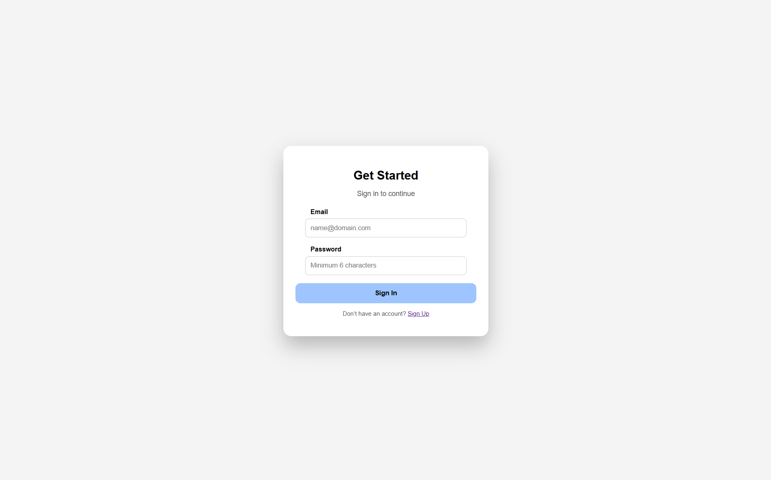

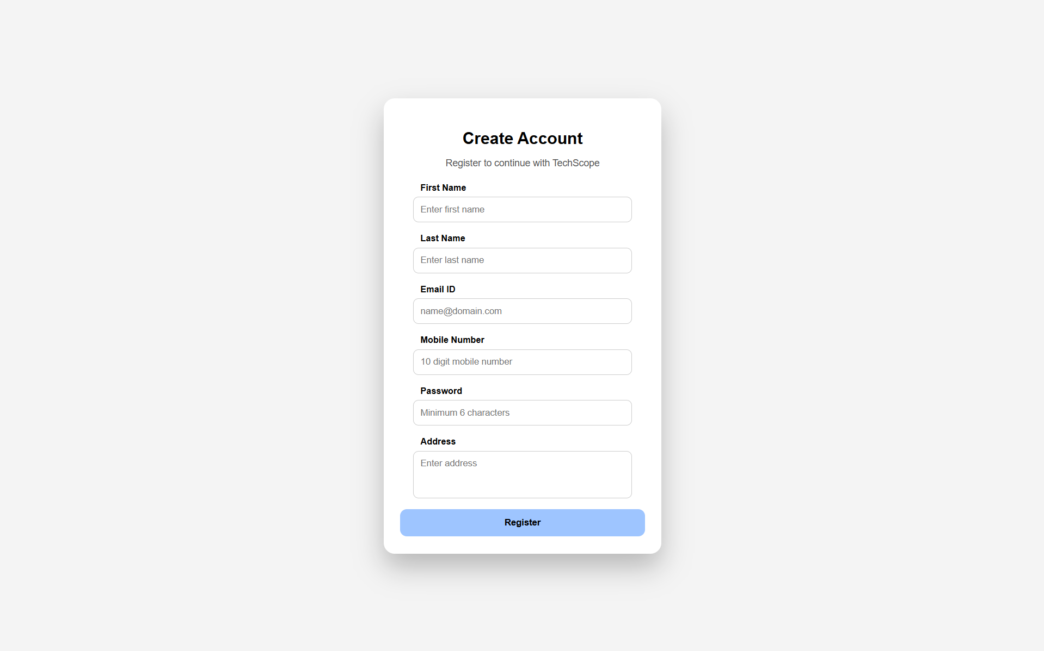
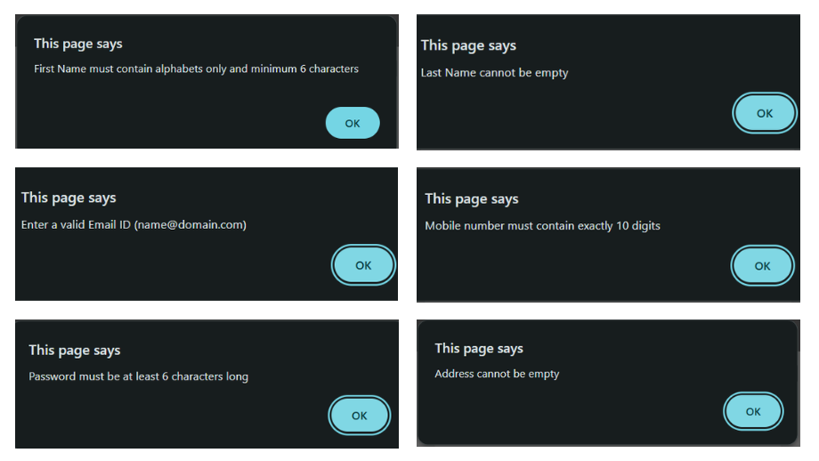
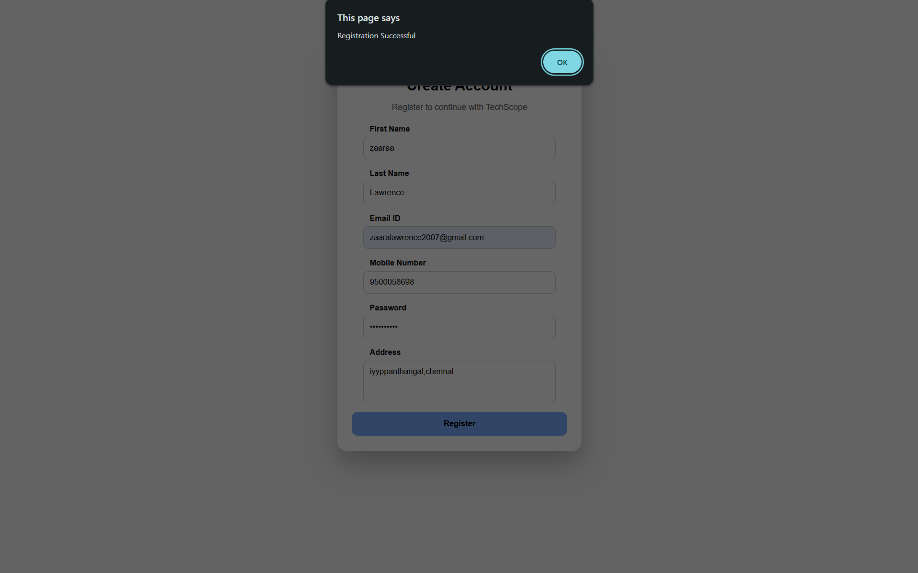
RESULT:
HTML page with Form is created and is validated using Javascript

